1. Decompressing the files ”gdc_download_20221219_141208.607259.tar” (from last section)as “gdc_download_20221219_141208.607259” file, like below:



1. To contaminate the all files into one folder:

Prepare the file:

2.1 Copy ”merge.pl” (fixed) and “metadata.cart.2022-12-19.json”(from last section) to the “gdc_download_20221219_141208.607259” file

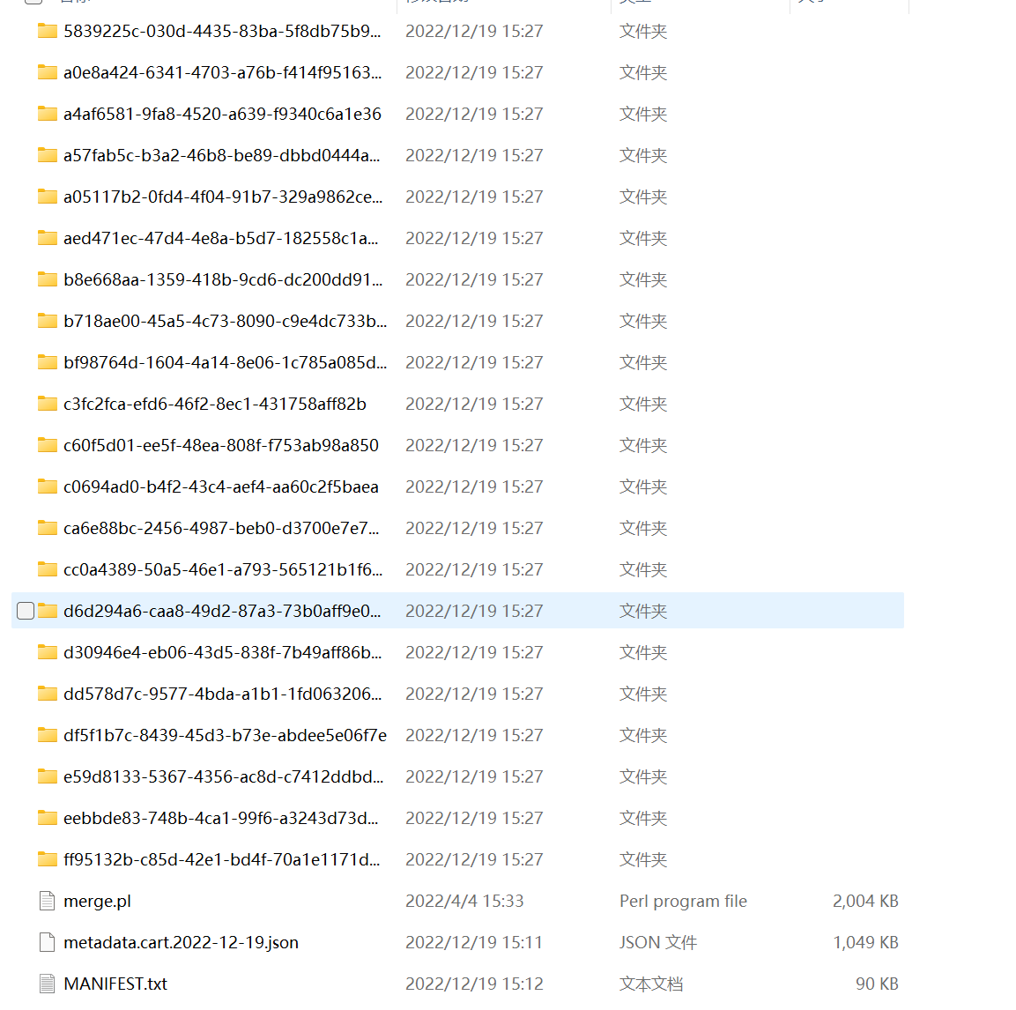

2.2.1 Search “CMD” in the computer and open it

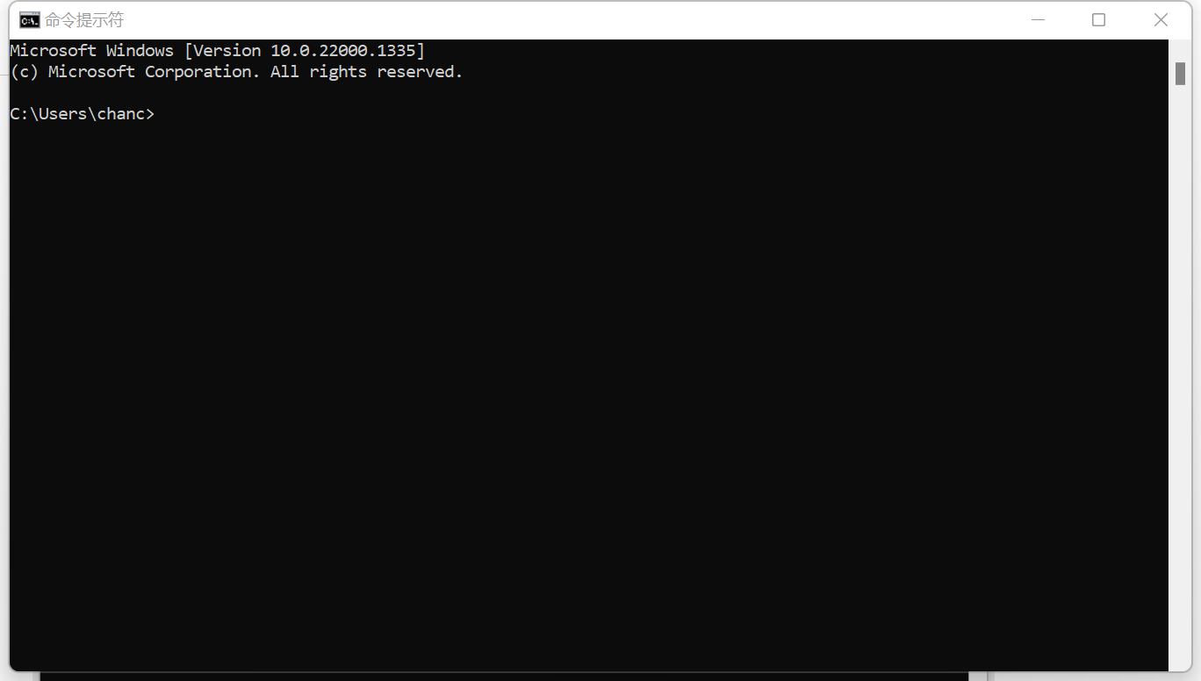

2.2.2 set up the store path: Usually default pathway is C:, if the document in the other disk, for example like mine in the D:, then input the “d:” and click enter

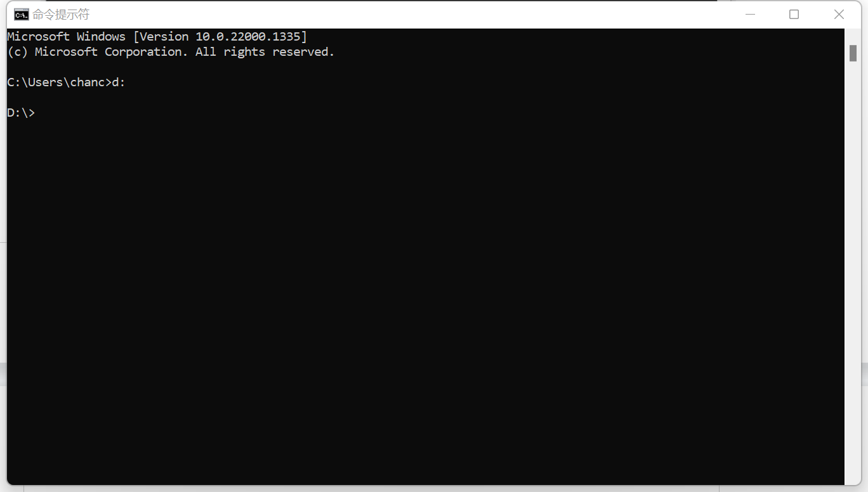

2.2.3 Define the specific stored path, for example mine is “D:\bioinforamtion\TCGA-WGCA\Bladdercancer\2.merge\gdc_download_20221219_141208.607259”, then input “cd+path” and click enter, like below:

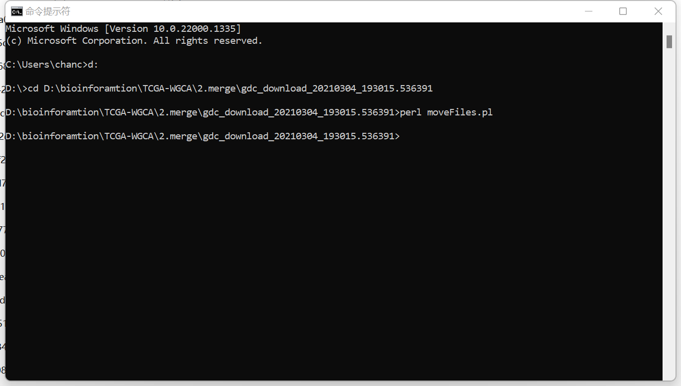

2.2.4 Input the “perl merge.pl metadata.cart.2022-12-19.json” and click enter

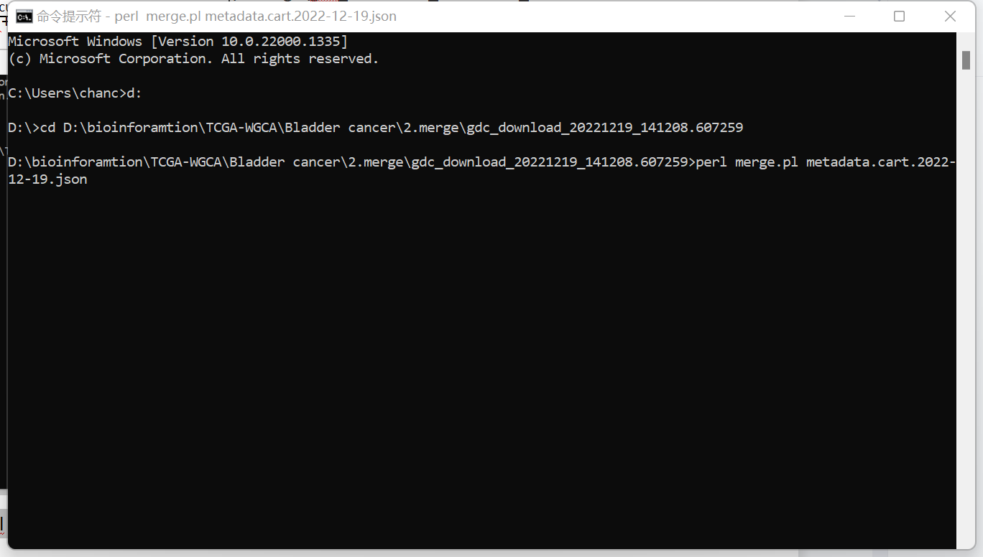

2.2.5 when the cursor back to the end, the process is finished and showed like below（normal and tumor samples count should be remember N=19; T=412）:

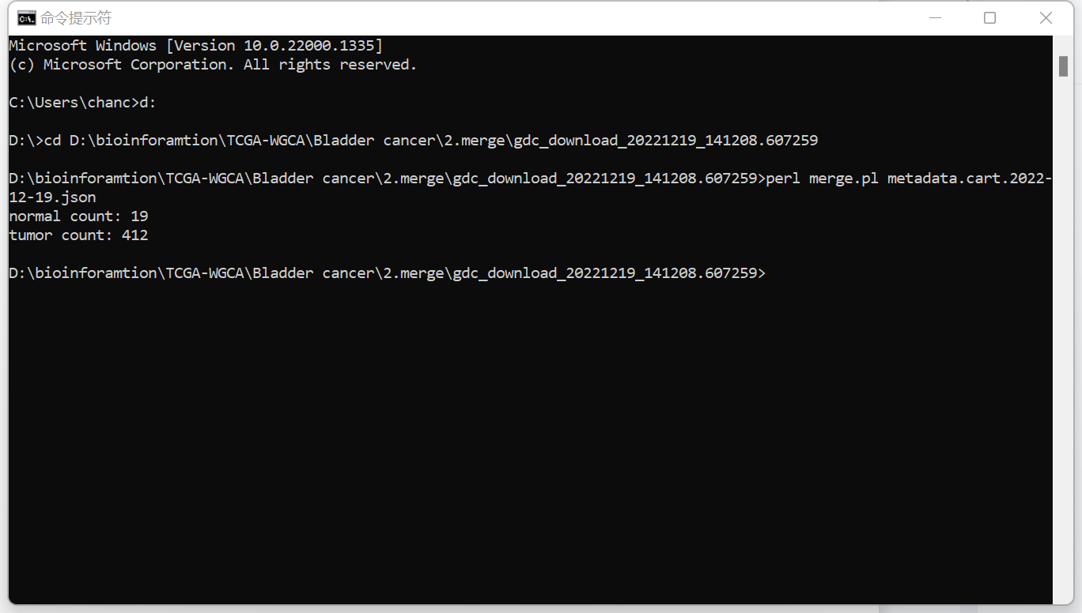

3.If the file named:”Symbol.txt” showed in the folder, means perl running successfully

